
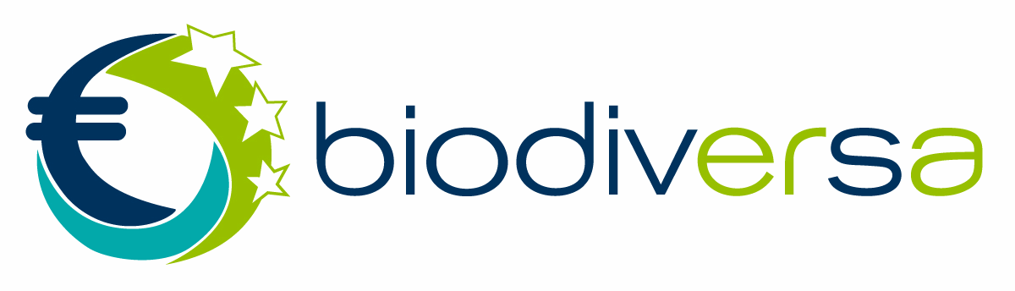


New BiodivERsA and Water JPI Call launched

2020-2021 COFUND Call for Transnational Research Proposals on “Conservation and restoration of degraded ecosystems and their biodiversity, including a focus on aquatic systems”

[NB: the call includes a focus on aquatic systems but all environments are eligible]

BiodivERsA and Water JPI are pleased to announce that their transnational 2020-2021 joint Call on “Conservation and restoration of degraded ecosystems and their biodiversity, including a focus on aquatic systems” is now open.

CALL PRIORITIES

This call will cover the following three non-exclusive themes:
- Studying the biological and biophysical processes at stake for conservation/restoration, and their interactions
- Assessing trade-offs and synergies between targets, benefits and policies for conservation and restoration
- Knowledge for improving the effectiveness and upscaling of conservation and restoration actions

This joint call includes a focus on freshwater aquatic systems but ALL ENVIRONMENTS (I.E. TERRESTRIAL, FRESHWATER AND MARINE) ARE ELIGIBLE.

ELIGIBILITY

Research teams will be invited to form transnational research consortia with eligible partners from minimum 3 countries participating in the call (including minimum two from EU Member States or EU Associated Countries).

For applicants from the overseas: provided the latter criterion is met (Partners from at least two different EU Member States or Associated Countries participating in the call), for proposals including Partners from outermost regions and overseas countries and territories participating in the call, the outermost regions and overseas countries and territories can be counted as a specific participating country (for the criteria: at least three different countries).

Proposals have to be exclusively written in English.

Looking for a partner or a project to join?
Use our Partner Search Tool available here
Join the Water JPI Researchers Forum on LinkedIn

EVALUATION CRITERIA

The research proposals will be evaluated across the following criteria:
- Step 1 (in the event of that a large number of pre-proposals is received and an evaluation of pre-proposals is performed): (i) fit to the scope of the call, (ii) scientific excellence (with a focus on novelty of the research proposed), and (iii) societal and policy impact;
- Step 2: (i) excellence; (ii) quality and efficiency of the implementation and (iii) impact (including societal / policy relevance and approaches to stakeholder engagement).

For both steps, it is also expected that the international added value of the projects is clearly presented. The detailed list of evaluation criteria to be used for this call is available in the call documents.

PARTICIPATING COUNTRIES

31 funding organisations from 27 countries are planning to join this call and have reserved – together with the European Commission – a total amount of over 20 Million Euro. Their participation in the call will be confirmed very soon.

Tentative list of participating countries
Austria, Belgium, Brazil*, Bulgaria, Czech Republic, Denmark, Estonia, Finland, France, Germany, Ireland, Latvia, Lithuania, Moldova, Morocco, Netherlands, Norway, Poland, Portugal (including Azores), Romania, Slovakia, South Africa, Spain, Sweden, Switzerland, Taiwan, and Tunisia

* Please, consult the Funding Organisation Rules for the information on the Brazilian States involved

Each Partner in a funded project will be preferentially funded by their national/regional organisation(s) participating in the call. Please note that each research Partner in a project must comply with the eligibility criteria and rules of its funding organisation.

CALL SCHEDULE

A two-step process will apply, with a mandatory submission of pre-proposals at the first step and submission of full proposals at the second step, via an Electronic Proposal Submission System (EPSS). The link to the EPSS will be available soon on the BiodivERsA and Water JPI websites.

Call timeline:
- Launch of the call: Monday 5 October 2020
- Deadline for pre-proposals submission (mandatory): Monday 7 December 2020, 16:00 CET (local time in Brussels)
Please note that the nature of the evaluation at the first step (pre-proposals stage) will depend on the number of pre-proposals received.
- If a very large number of pre-proposals is received, a first scientific evaluation of pre-proposals will be organized and the deadline to submit full proposals will be the 3 May 2021.
- Otherwise, only an eligibility check of pre-proposals will be performed and the deadline to submit full proposals will be the 15 March 2021.
The actual deadline to submit full proposals will be communicated by the end of December 2020.

MORE INFORMATION

Make sure to consult the complete announcement of opportunities and all supporting documents as well as Funding Organisation Rules on the BiodivERsA website and on the Water JPI website.

SAVE THE DATE: an information webinar will be organised on 27 October 2020, from 14:00 to 15:30 CET to answer all your questions about this call.
To participate, please register here.

- For general information on the call, please contact the Call Secretariat: Patricia Vera and Maja Kolar, BiodivRestore.cs@aei.gob.es
- For technical questions regarding the EPSS, please contact the EPSS technical helpdesk: Taavi Tiirik, epss.biodivrestore@g.etag.ee
- For GDPR questions, please contact biodiversa@fondationbiodiversite.fr

